**ATTENTION 8TH GRADE BAND PARENTS AND STUDENTS:**

We are planning an optional trip to Michigan’s Adventure in Muskegon on THURSDAY, MAY 28TH, 2014.

The 8th grade band students will be performing at Michigan’s Adventure, presumably marching music or possibly something from the Spring Concert which should be fresh in students’ minds at that point.

The cost will be $22, and will include unlimited access to all of the park’s features and also lunch for the day. Students WILL be responsible for bringing money for dinner on the way home when we stop for fast food. The *projected* time we will be gone is from 7:45 a.m.-6:30 p.m.

In order for students to attend, they will need to return the following permission slip. In addition, $10 will be due on Friday, February 13th with the remainder ($12) due on Thursday, March 26th. PLEASE NOTE THAT STUDENTS ARE WELCOME TO PAY THE TOTAL AMOUNT DUE AT ANY TIME BEFORE MARCH 26TH. **I am also looking for 4 - 5 chaperones, although the chaperones will have to still pay the full admission price of $22**. If you have questions or need to make alternate payment arrangements please contact Mrs. Livengood at rlivengood@brandywinebobcats.org or 269-683-4800.

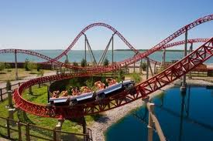

I give my student, _____________________________________, permission to attend the Michigan’s Adventure trip on Thursday, May 28th, 2014. By signing this slip, I give my student permission to participate in any rides/activities that the park has and also for transportation to and from the event with the school.

Please list any allergies or medical issues below or on the back of this form, or notate if you or a spouse will be chaperoning:

Parent Signature_______________________________________ Date____________________